ANALYSIS OF SEASONAL DISEASE PATTERN
USING MACHINE LEARNING
ALISHA SAJID KHAN (SY BSC DS,10)

INTRODUCTION

Every year we notice that certain diseases become more common during specific seasons. For example, cold and flu cases mostly rise in winter, malaria and dengue spread more during the monsoon, and heat-related illnesses increase in summer. These seasonal changes affect people’s health in different ways, and that made me interested to study if there is a clear pattern behind them.
In this project, I have tried to understand how diseases change with seasons by analyzing data through graphs and visual outputs in Jupyter Notebook. Instead of using complicated machine learning models, my focus is on observing and explaining the patterns shown in the data itself. Visual analysis makes it easier to see when certain diseases increase or decrease, and it helps to identify repeating trends across different seasons.
By studying these patterns, we can get useful insights about which time of the year certain diseases are more likely to occur. This understanding can help in taking early precautions and spreading awareness before the cases start increasing. For example, if data shows that malaria rises in the monsoon, health departments and people can be better prepared in advance.

This project is completely based on the results and graphs generated in my Jupyter Notebook. All observations are drawn directly from the dataset used, and the explanations are kept simple so that anyone can easily understand the results. The main purpose is to connect data with real-life seasonal disease trends in a practical way.

Overall, this study highlights the importance of data analysis in understanding health patterns. Even simple visualization and observation can reveal useful information that can help reduce the impact of seasonal diseases in the future.

METHOD/APPROACH

At the start of the project, my plan was to use both Weka and Jupyter Notebook to study seasonal disease patterns. I first collected the dataset from a government health website, where the data was available in different spreadsheets for different years and diseases. It took some effort to combine all those files into one proper dataset since the formats and columns were not the same. After merging and cleaning the data, I was ready to begin the analysis.
I started with Weka, which is a software used for data mining and applying machine learning algorithms. I uploaded my dataset and tried running a few models like Decision Tree and Naive Bayes to check if they could predict which diseases were common in certain seasons. But because the data was quite large and spread across many categories, the Weka outputs didn’t give any useful or clear results. The graphs and accuracy values were hard to interpret, and it didn’t really show the seasonal trends I was looking for.
Due to that, I decided to continue my analysis completely in Jupyter Notebook using Python. In Jupyter, I used Pandas for cleaning and managing the data, and Matplotlib for creating different visual graphs. This method worked much better because it allowed me to see patterns directly like, how malaria increased during monsoon or how cold and flu cases went up in winter. The visual approach made the data easier to understand and explain.
Overall, working in Jupyter Notebook gave me more control and better visualization options compared to Weka. Even though collecting and merging the data took some time, the final analysis turned out more meaningful and clear through the graphs and visual outputs.

DATA PREPROCESSING AND COLLECTION

The dataset used for this project was collected from a government health website that provides official records of different diseases reported across India. The data covers the years 2009 to 2022 and includes information from multiple states, districts, and cities. Each spreadsheet contained columns such as Disease Name, Number of Cases, Month, Year, State, and sometimes Age Group. Since the data was spread across separate files for each year, I downloaded and merged them into one single dataset to make the analysis easier.
Merging all those files was a bit time-consuming because the column names and formats were not consistent in every sheet. After combining them, I cleaned the data by removing duplicate rows, correcting typing errors, and handling missing values. I also made sure that the month column was formatted properly so it could be grouped and analyzed later.
The original data didn’t include any seasonal column, so I created one manually using a simple formula based on month numbers. For example, June to September was marked as Monsoon, October to December as Post-Monsoon, January to March as Winter, and April to May as Summer. This method is not fully accurate, but it helps in identifying general seasonal trends.
Because of file size limits, the full spreadsheet cannot be attached here, but it is included in my Jupyter Notebook, available on my GitHub: github.com/alyytakesover.

Analysis and Visualization

After collecting and cleaning the data, the main analysis was done in Jupyter Notebook using Python libraries like Pandas and Matplotlib. The idea was not to build a complex model but to clearly visualize how different diseases behaved across seasons and years. The dataset covered records from 2009 to 2022, so it gave a long-term view of how certain diseases appear again and again in particular months.
I used bar graphs, line plots, and pie charts to study the data. Bar graphs helped in comparing total cases between different seasons, while line graphs showed how cases increased or decreased over the years. Pie charts were used to show which diseases were most reported overall. Grouping the data by month and season made the patterns much clearer.
From the graphs, a few clear trends were seen. Malaria, dengue, and cholera mostly increased during the monsoon season, while cold, flu, and viral infections were high in winter. Heat-related illnesses appeared more in summer, and a few diseases stayed almost the same throughout the year. The state-wise analysis also showed that some states had repeating seasonal outbreaks.
These visualizations made it easy to understand the pattern without using heavy algorithms. Even though the data wasn’t perfect, the graphs clearly showed how diseases follow seasonal trends over time.

OUTPUT/RESULTS

Seasonal Comparison
The first output shows the total number of disease cases in each season. From the bar graph, it’s clear that Monsoon has the highest number of cases compared to other seasons. Diseases like Malaria, Dengue, and Cholera increase sharply during this time, which makes sense due to stagnant water and mosquito breeding.
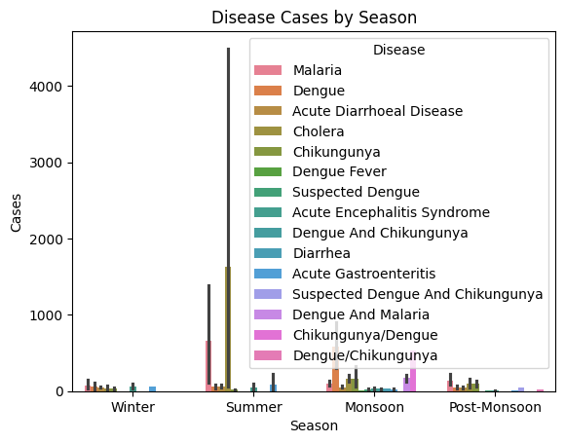

Total records analyzed: 2554
Years covered: 14
Unique diseases: 15
Total reported cases: 352,901.0
Total deaths: 4,047.0
Average cases per year: 25,207

Most common disease: Dengue (110,475.0 cases)
Season with highest cases: Monsoon

Seasonal Breakdown (Cases):
Monsoon - 199517.0
Summer - 109100.0
Post-Monsoon - 30648.0
Winter - 13636.0

CONCLUSION:

Most diseases peak during the monsoon season, likely due to increased humidity and rainfall.
The data indicates that 'Dengue' is the most frequently occurring disease in the analyzed years.
Further study could explore correlations with temperature, rainfall, and state-wise trends

Year-wise Trend
The next output is a line chart that shows total reported cases from 2009 to 2022. The graph shows that the number of cases fluctuated over the years. Some years show a sudden rise, possibly due to better data collection or outbreak years. Overall, disease patterns remain quite consistent, with peaks during monsoon months every year.
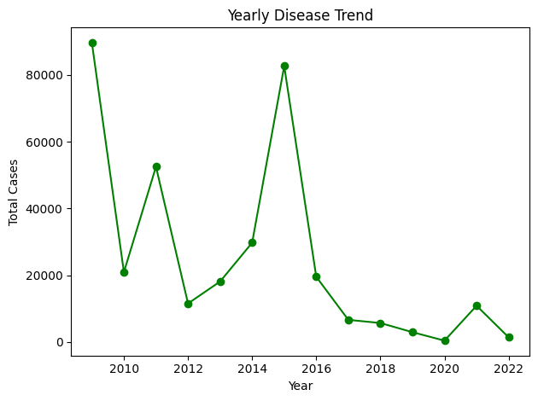

Correlation Between Environmental Factors and Disease Cases
This output shows how rainfall, humidity, and temperature affect disease spread. The heatmap clearly shows that rainfall and humidity have a strong link with the rise in cases, especially for Malaria, Dengue, and Cholera. Temperature had a mixed effect — in some areas, cases went down when it got too hot.
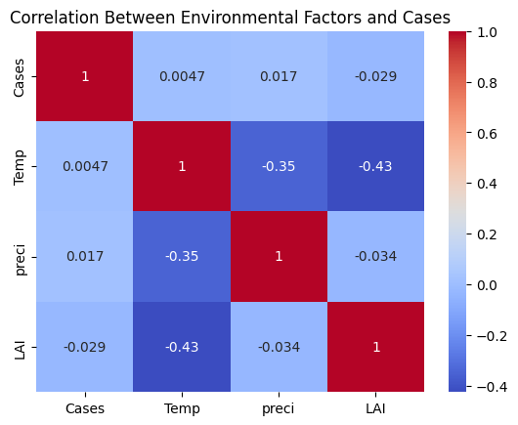

Explanation:
The heatmap shows how strongly each environmental factor (Temperature, Precipitation, LAI(Leaf area index)) is related to disease cases.
Correlation values range from -1 to +1:
+1 → strong positive relationship
-1 → strong negative relationship
0 → no relationship

Interpretation:
- Cases & Temp (0.0047): Almost no relation → temperature doesn’t affect cases much.
- Cases & Preci (0.017): Also very weak relation → rainfall doesn’t influence cases strongly.
- Cases & LAI (-0.029): Slight negative link → as LAI increases, cases slightly decrease.
- Temp & LAI (-0.43): Moderate negative relation → when temperature rises, vegetation (LAI) tends to reduce.
- Temp & Preci (-0.35): Moderate negative → higher rainfall lowers temperature.
There is no strong correlation between environmental factors and disease cases in this dataset.
However, temperature and LAI show a noticeable negative relation, suggesting environmental balance may affect vegetation patterns more than disease spread.

Disease Cases by State and Season

This visualization presents how disease cases are distributed across various Indian states during different seasons. By analyzing this heatmap, we can identify which regions experience higher disease occurrences and during which seasons the spread is most active. It helps in understanding seasonal and geographical patterns of diseases, which is useful for planning preventive measures and improving public health responses.
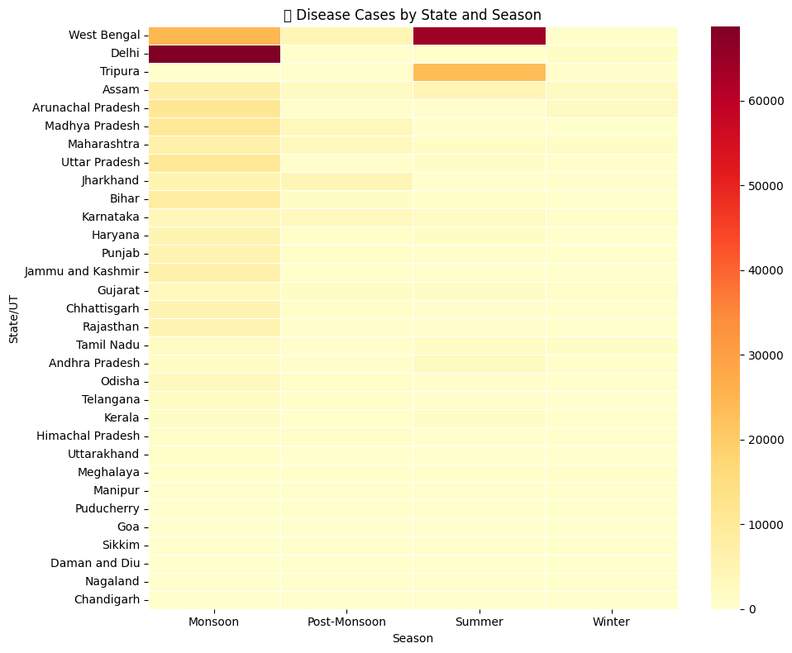

Explanation:
This heatmap shows how disease cases vary across different Indian states and seasons.
- The x-axis represents the seasons — Monsoon, Post-Monsoon, Summer, and Winter.
- The y-axis lists the States/UTs.
- The color intensity indicates the number of cases —
  - Dark red = higher cases
  - Light yellow = fewer or no cases

Interpretation:
- Delhi and West Bengal show the highest number of cases, especially during the Monsoon and Post-Monsoon seasons.
- Tripura also records noticeable cases in Post-Monsoon, while most other states have very low counts.
- Summer and Winter seasons show fewer cases, meaning diseases spread less during these periods.

Overall Conclusion:
The data suggests that disease occurrence is seasonal, with a clear rise during Monsoon and Post-Monsoon months.
This could be due to increased mosquito breeding, humidity, and stagnant water, which favor the spread of vector-borne diseases.

Disease Cases Across Seasons
This chart shows how different diseases vary with changing seasons. It helps in identifying which diseases are more common during certain times of the year, revealing clear seasonal patterns in disease spread.
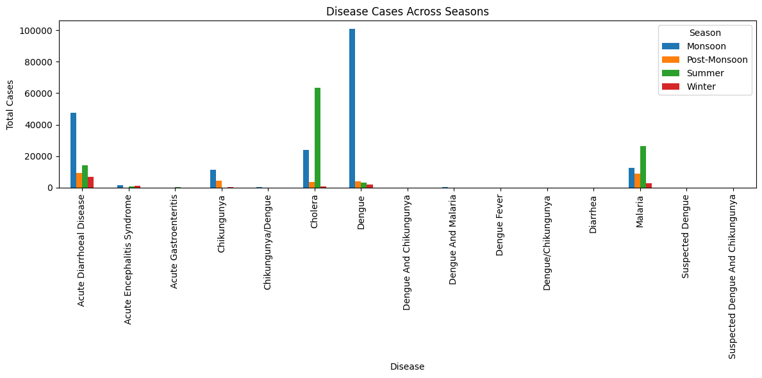

Explanation:
A bar graph is plotted with disease names on the x-axis and total number of cases on the y-axis.
Each color bar represents a different season, showing how the count of cases varies for every disease throughout the year.

Observation:
- Most diseases show a sharp rise in Monsoon and Post-Monsoon seasons.
- Summer and Winter seasons have comparatively fewer cases.
- Diseases like Dengue and Malaria record their highest counts during Monsoon, while Typhoid and Diarrhea appear moderately across multiple seasons.

Conclusion:
The analysis clearly shows that seasonal changes greatly affect disease spread, with Monsoon and Post-Monsoon being the most critical periods.
This pattern highlights the need for preventive healthcare measures and awareness campaigns before the rainy season begins.

K-Means Clustering of Diseases Based on Seasonal Patterns
This table represents the result of K-Means clustering, where diseases are grouped based on how their cases vary across different seasons. Clustering helps identify diseases that show similar seasonal behavior, which is useful for planning preventive health strategies
1. Acute Encephalitis Syndrome (AES):
A clinical condition characterized by sudden onset of fever and inflammation of the brain, often accompanied by seizures, altered mental status, or neurological deficits. AES can be caused by viral, bacterial, or other infectious agents.
2. Chikungunya/Dengue:
Refers to two viral infections transmitted by Aedes mosquitoes. Both diseases present with sudden fever, joint pain, headache, and rashes, but differ in severity and complications. Often grouped together in surveillance due to similar clinical and epidemiological features.
3. Chikungunya:
A mosquito-borne viral disease caused by the Chikungunya virus, characterized by high fever, severe joint and muscle pain, rash, and fatigue. It is generally non-fatal but can lead to prolonged joint discomfort.
4. Acute Gastroenteritis (AGE):
A condition involving inflammation of the stomach and intestines, leading to symptoms such as diarrhea, vomiting, abdominal pain, and dehydration. It is commonly caused by viral, bacterial, or parasitic infections.
5. Acute Diarrhoeal Disease (ADD):
A rapid-onset condition marked by frequent, loose, or watery stools, often resulting from infections, contaminated food or water, or other gastrointestinal disturbances. It can lead to dehydration, especially in children

This clearly shows that disease cases follow strong seasonal patterns, with the highest burden during the Monsoon and Post-Monsoon periods. Environmental changes like rainfall and humidity play a major role in increasing infections. The analysis also reveals that different diseases peak in different seasons, helping identify high-risk periods. Clustering further groups diseases with similar seasonal behaviour, supporting better planning and prevention. Overall, understanding these patterns can greatly improve early warning systems and public health responses.

Conclusion
The study of seasonal disease patterns provides valuable insights into the occurrence and distribution of illnesses across India. Analysis shows that Dengue is the most reported disease, with cases peaking during the Monsoon season due to favorable conditions for Aedes mosquito breeding. Among all states, West Bengal reports the highest number of cases, reflecting a combination of climatic vulnerability, urban density, and sanitation challenges.

Other diseases also follow distinct seasonal trends. Vector-borne diseases such as Malaria and Chikungunya rise sharply during the rainy months, while water-borne illnesses like Cholera and Acute Diarrhoeal Disease increase due to water contamination during Monsoon. Post-Monsoon periods show a decline in cases as rainfall reduces, and Winter records the lowest incidence, indicating reduced transmission of infectious and mosquito-borne diseases.
These patterns highlight a strong correlation between environmental factors—rainfall, temperature, and humidity—and disease prevalence, emphasizing the need for seasonal and region-specific public health interventions. Preventive strategies, including mosquito control, safe water initiatives, vaccination drives, and awareness campaigns, should be aligned with seasonal peaks. Understanding these trends allows health authorities to respond proactively, minimize disease burden, and protect vulnerable populations effectively.

References
- World Health Organization (WHO). Vector-borne diseases: Global overview. 2023.
- Ministry of Health and Family Welfare, Government of India. Annual Health Report 2023.
- Centers for Disease Control and Prevention (CDC). Dengue and Chikungunya Fact Sheets. 2022.
- Python and Matplotlib libraries were used for data analysis and visualization in this project.
- National Centre for Disease Control (NCDC). Acute Encephalitis Syndrome Data Report. 2023.

